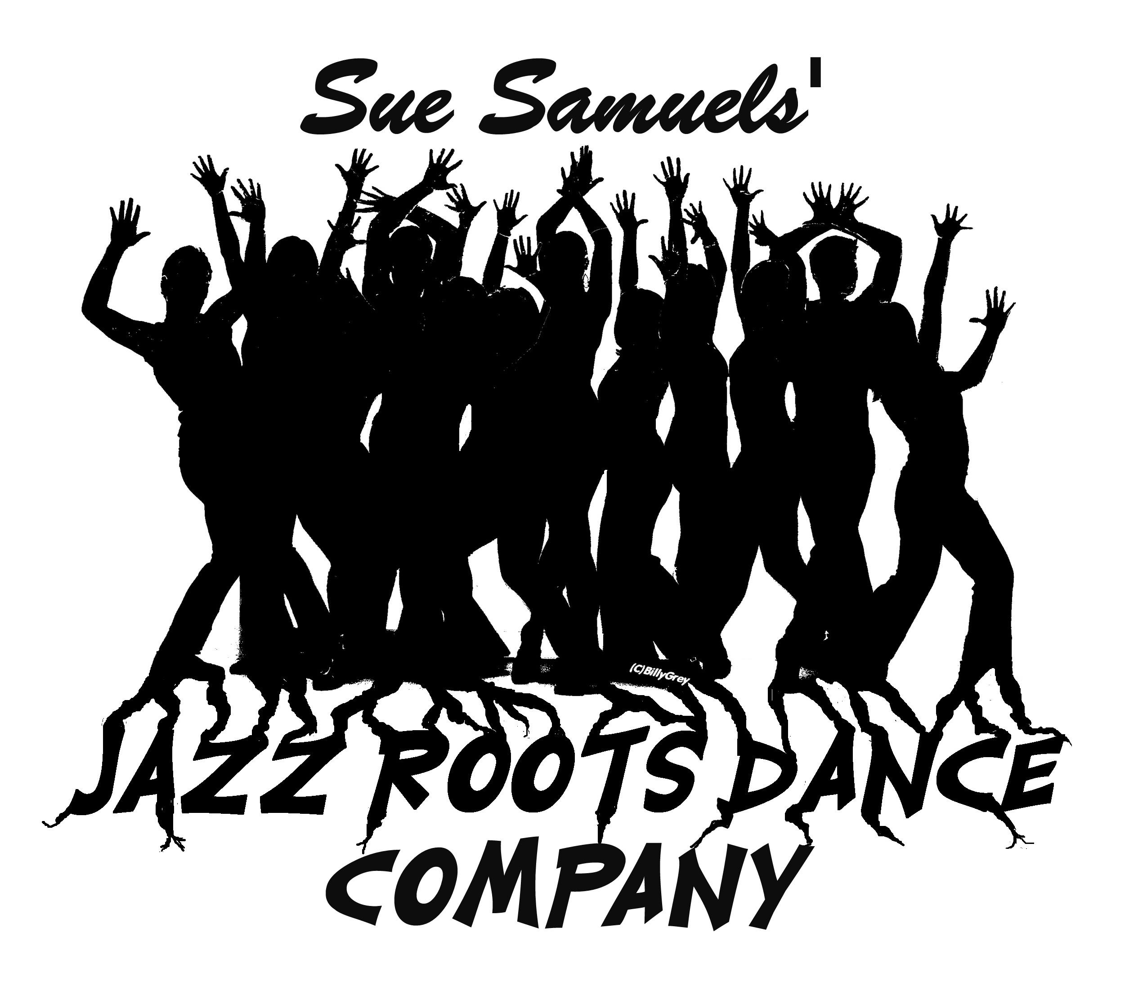
Performance Reel

“Thank you again for the truly enlightening performance –
reminded me what jazz for jazz’s sake really looks like!”

Joan Finkelstein
Director of Dance
New York City Department of Education.

“SHAFT”:Photo credit:Jan LaSalle

www.jazzrootsdance.com

JAZZ ROOTS DANCE COMPANY

Jazz Roots Dance Company was formed in 2009 by Sue Samuels, Artistic Director and world-renowned Jazz Dance icon. The company is dedicated to the preservation of the classic jazz form, and aims to entertain and educate all generations about the roots of classic jazz dance.

The diverse styles that contribute to the foundations of Jazz dance makes the Company’s body of work varied in musicality. For example it includes Swing, Theater Dance, Lyrical, Classic Jazz, Latin Jazz as well as music with different time signatures. Because of this variety, the Company can perform at many different events, such as corporate events, receptions and big parties. The entire repertoire is family friendly.

In April 2013, the Company presented its First Season and Gala at the Salvatore Capezio Theater at the Peridance Capezio Center. The Company premiered “Blackbird”, an innovative, exciting piece that met with a wonderful audience reaction, and “The Swing is the Thing” an original composition performed to live singing. Also included were audience favorites Papa Was A Rolling Stone, Fly Me To The Moon, Take 5, Rat Pack and Fever.

Jazz Roots Dance recently went on tour to L.A to perform at the Tri Art Festival 2013. Their performance met with an enthusiastic reception and a great review.

The Company has an established record of performing with such organizations as Jazz Choreography Enterprises and the NYC Jazz Choreography Project, Choreographer’s Canvas, the Undertoe Dance Festival and the Young Choreographer’s Festival just to name a few. They have performed at prestigious New York City venues such as Symphony Space, Manhattan Movement and Arts Centre and the Buttenweiser Hall at the 92nd Street Y. They have also performed at numerous festivals, such as FAB (Fourth Arts Block).

Jazz Roots Dance is an international Company. The dancers are talented professionals from such diverse countries as Italy, Argentina, Mexico, the UK, Germany and Japan in addition to the US.

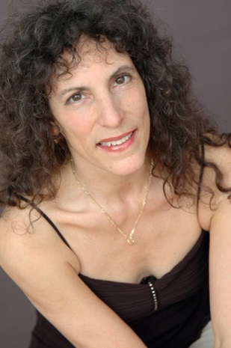
SUE SAMUELS,
ARTISTIC DIRECTOR

Sue Samuels (Choreographer, Master Teacher, Performer, Artistic Director) has established herself as one of the staples of the performing arts community of today. With over 40 years of experience, her expertise is often sought after for mentoring and coaching purposes by professionals and aspiring artists from around the world. Her students have included numerous stage, film and TV stars including Melba Moore, Brooke Shields, Irene Cara and Dominique Dawes.

Performance and choreographic credits include lead dancer and assistant choreographer in such shows as “The Fifth Dimension On Broadway” at the Uris Theater, "Got Tu Go Disco" at the Minskoff Theater on Broadway, “The Sylvie Vartan Show” and "The Johnny Hallyday Show" in Paris, "The Brazil Export Show" in Rio de Janeiro to name a few. Televised credits include "All My Children," "Jerry Lewis Telethon," "Contemporary Women," "The Arthritis Telethon" with Melba Moore," "Zoom," and numerous commercials and industrials for Dr. Pepper, 7 Up, Wheat Thins, Head & Shoulders, Adidas, Glaxo, Members Only among others. Sue’s most recent performing credit was two years travelling nationally for the Schiff Vitamin Company as a “Move Free Dancer”.

Ms Samuels is the Artistic Director of Jazz Roots Dance Company, which she formed in 2009 to preserve and promote the Classic Jazz Dance style, a real American dance form. Ms Samuels recently produced the Company’s First Season and Gala at the Peridance Capezio Center and took Jazz Roots Dance on tour to L.A.

Choreography has been the cornerstone of Ms. Samuels' artistic career and most of the Jazz Roots Dance Company repertory is choreographed by her. She has been commissioned to choreograph works for Companies in Japan, Finland and Brazil and she holds workshops for students of all levels to learn and perform her choreography.

Sue Samuels was the co-founder/owner of Jo Jo's Dance Factory in New York City. Ms Samuels was also the director of the Jazz Department and founded the Jazz program for Children at the Ft. Lauderdale Ballet in Florida, and ran her own Children's program in Boca Raton and Fort Lauderdale, Florida. Ms Samuels was commissioned to teach at New York University in the Cap 21 program with theater majors, as well as Olympic Gymnastic Instructors in Tokyo, Japan. Other teaching credits include The Broward Civic Ballet, Frank Hatchett's Professional Childrens Program, Dance Masters Association, and The Dance Company of Haiti. She continues to travel around the world for master classes often held for teachers & Instructors. In turn, groups come to study her unique Jazz Style. She has been on the faculty at Broadway Dance Center since 1986 and also teaches at the Peridance Capezio Center.

The blending of jazz dance with her classical ballet training makes Ms Samuels’ style unique. This classic jazz style emphasizes strong and proper body alignment and clean technique. Her classes include a jazz barre warm-up, floor exercises, which she accompanies on Conga Drum, and classic jazz isolations. Her choreography is based on the dynamics of musicality using strong movements which emanate from the hips and chest, creating an overall visual picture of the music.

Ms. Samuels training began with the Broward Civic Ballet in Florida where she performed with the company for six years and became the first soloist. She also studied in New York with the distinguished Madame Swoboda of the Ballet Russe de Monte Carlo. Her jazz training includes JoJo Smith and Frank Hatchett as well as tap with Judy Bassing, and voice with William Daniel Grey

PERFORMANCES AND PRESS

- JAZZ ROOTS DANCE COMPANY SEASON AND GALA , Salvatore Capezio Theatre at the Peridance Capezio Centre, April 27th and 28th 2013. Review here on Examiner.com Interview with Sue Samuels here on Inside NYC Dance

- TOUR TO LA, Tri-Art Festival San Pedro, CA, September 21st 2013. Review here from Harbor Tides

- CORPORATE EVENTS/PRIVATE PARTIES
  - D’Luscious Champagne Launch, February 4th 2013, The DL and Dinner on Ludlow
  - Opera Event in Queens, NYC, May 15th 2011

- BROADWAY DANCE CENTER IN-STUDIO PERFORMANCES, October 20th 2013 and February 16th 2014. Review of October 2013 performance here on Examiner.com

- NEW YORK JAZZ CHOREOGRAPHY PROJECT/JAZZ CHOREOGRAPHY ENTERPRISES 2010 to date

- FOURTH ARTS BLOCK (FAB) FESTIVAL, September 28th 2013

- BOB at the Abingdon Theater Arts Complex, September 2013

- PERIDANCE FACULTY SHOWCASE, 2011 to 2013

- YOUNG CHOREOGRAPHER’S FESTIVAL, June 15th 2013 at Symphony Space

- TOYS FOR TOTS, December 8th 2012 at the Salvatore Capezio Theater at the Peridance Capezio Center

- CHOREOGRAPHER’S CANVAS at Manhattan Movement and Arts Center 2011 to date

- UNDERTOE DANCE FESTIVAL at the Harkness Dance Center, 92nd Street Y (Buttenweiser Hall) 2011 to 2013

- DANCE SAFARI (RIVERSIDE DANCE FESTIVAL), September 17th and 18th 2011

- ACTOR’S FUND NURSING HOME, August 20th 2010

- AILEY CITICORP THEATER, March 21st and 22nd 2010

JAZZ ROOTS DANCE COMPANY REPERTOIRE

Blackbird/Bye Bye (8 Min. 10 Sec) - Danced together as listed below: Click here for video.
Blackbird (3 Min.) - An innovative, exciting and atmospheric audience favorite, where the lead dancer is suspended for the whole number.
Bye Bye Blackbird (5 Min. 10 Sec) - Classic Bob Fosse choreography, restaged by Sue Samuels.
Black Sweat (4 Min.) - Bold, jazzy and spicy solo piece to Prince music.
Down into Muddy Water (3 Min, 41 Sec)– Choreographed by Bob Boross in the style of Matt Mattox.
The Emerald Forest (6 Min.) - An “animalistic” influenced jazz piece set in a visual forest.Click here for video.
Fever (4 Min. 30 Sec) - A sultry, jazz dance with theatrical flair. Click here for video.
Fly Me To The Moon (2 Min. 28 Sec) - A Theatrical duet sung by Frank Sinatra with the Count Basie Orchestra. Click here for video.
For Dancers Only (3 Min 43 Sec) – Choreographed by Alan Onickel in the style of Phil Black.
Give My Regards To Broadway (3 Min. 30 Sec) - A splashy blast from the past of Broadway style choreography danced to the original voice recording of George M. Cohen.
It's About Time (8 Min. 30 Sec) – includes “All Blues” and “Take 5” danced together as listed below. A classical jazz piece set to three different pieces of music which have meters other than eight.

All Blues – A Jazzy number set in a 3/6 time signature.

Take 5 (5 Min. 28 Sec) - A Classic jazz expression of Dave Brubeck Quartet, top selling single of the 20th Century. Click here for video.

Jingle Jazz (5 Min. 15 Sec) - An upbeat holiday piece to a mix of several classic Christmas songs. Click here for video.
Let's Go Dance (3 Min.) - A lively, comical dance piece set in the pre-jazz era. Click here for video

Listen (3 Min. 42 Sec) - A lyrical trio set to Beyonce's song from the Dream Girls Soundtrack. Click here for video.
Papa Was A Rolling Stone (11 Min.) - An energetic group piece in the classical jazz style. The choreography illustrates the musical composition as though the dancers bodies are singing. Click here for video.
Rat Pack (4 Min. 53 Sec) - Broadway theatre jazz set to a medley of Frank Sinatra and Sammy Davis Jr. Click here for video.
Shaft Medley (8 Min.) - Ellie's Love Theme/Theme From Shaft; Danced together as listed below. Click here for video.
Ellie's Love Theme (3 Min. 30 Sec) - Classic lyrical jazz originally choreographed by JoJo Smith and restaged for the company.
Shaft (4 Min. 30 Sec) - An up-tempo jazz piece set in a true “classic jazz” style.
Steppin’ Out With My Baby (4 Min 11 Sec) – Choregraphed by Tammy Oha’ra in the style of Luigi.
The Swing Is The Thing (4 Min.) - A bouncy Swing number danced to the original composition written and recorded by Billy Grey with the Widespread Jazz Orchestra.
Click here for video.

PHOTOS
“FEVER”: photo credit: Jan LaSalle
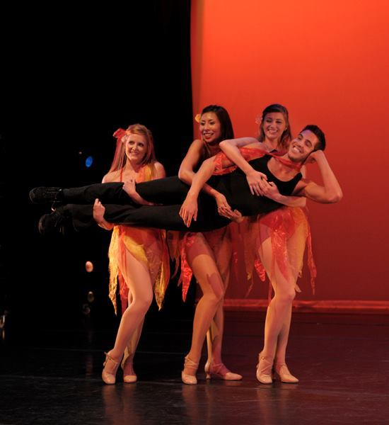
“PAPA WAS A ROLLING STONE”: Photo credit: Nanci France-Vaz
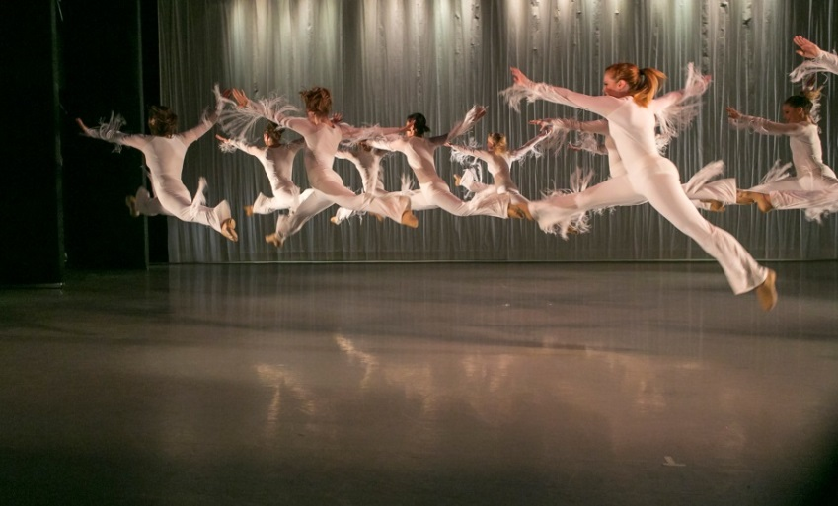
“SHAFT”: Photo credit: Jan LaSalle
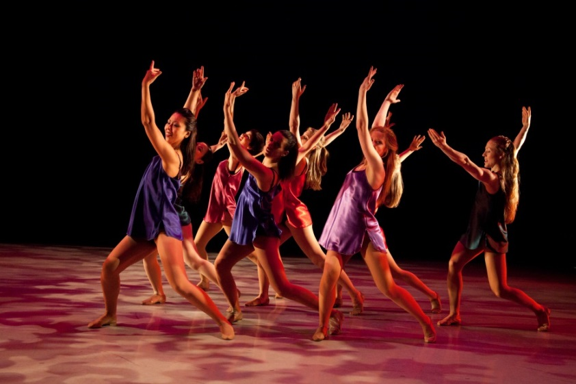

BOOK US!
Contact: Elka SamuelsSmith 212-262-1394
DivineRhythmNYC@gmail.com

COME DANCE WITH US!
If you travel to New York, come take a Jazz Roots Dance class. If not, let Jazz Roots Dance come to you. Jazz Roots Dance Company’s Artistic Director Sue Samuels and company members teach as part of intensives, residencies, one-day master classes, or half-day workshops.
Click here to book us today! divinerhythmnyc@gmail.com

For more information please contact our Booking Manager, Elka Samuels Smith
At 212-262-1394 or divinerhythmproductions.com

PERFORMANCES AND DEMONSTRATIONS
JAZZ ROOTS DANCE COMPANY IN CONCERT
Jazz Roots Dance Company’s full ensemble of dancers showcases recent works and pieces from their repertory in a variety of settings from traditional theaters and black box spaces to convention centers and festivals.

JAZZ ROOTS DANCE SMALL ENSEMBLE PERFORMANCE
Featuring either four or five dancers, this small ensemble is perfect for intimate theaters, informal performance areas, and other non-traditional performance spaces. While providing the same dynamic performance experience as Jazz Roots Dance Company In Concert, this is the perfect option for a smaller season budget.

JAZZ ROOTS DANCE COMPANY: GUEST ARTIST APPEARANCE
Offering solos, duets or group works from our repertory, our guest artist appearances can supply a complementary shot of energy to your variety shows or shared concert programs, whether at theaters, universities, dance festivals, music festivals, elementary and secondary schools, libraries, businesses, conferences or convention halls.

“GET JAZZED!”®: THE EDUCATION SHOW
“Get Jazzed!” ® is the company’s acclaimed audience-interactive lecture-demonstration, a show that is as exuberantly entertaining as it is lastingly educational. The subject is JAZZ DANCE, the universal language of communication that tells us how to feel and our bodies how to move. These lecture-demonstrations work well as family performances or for student groups ranging in age from kindergarten through high school. The performances can be presented in a variety of settings including theaters, schools, libraries, hospitals, and professional conferences.

JAZZ ROOTS DANCE COMPANY IN RESIDENCY
Jazz Roots Dance Company offers several options to suit you – choreographic residencies, teaching residencies, and residencies concluding with Jazz Roots Dance Company In Concert.
Our residencies can be conducted by the entire company, a team of two-to-four members, or by the artistic director, the associate artistic director, or a senior company member. We can work with your students at your dance studio, secondary school, university, or community center for anywhere from two days to six months or longer.
During that time, company members can teach classes in; Jazz Roots Dance Technique®;Jazz Roots Dance Company Repertory, Choreography, The Mind-Body Connection® for Injury Prevention; The Mind-Body Connection® for Learning Choreography; I Love Jazz Dance® for the Absolute Beginner.
In Choreographic Residencies, two company members can set an existing piece of choreography from company repertory, or the artistic director can create new commissions, featuring Jazz Roots Dance Company’s rhythmically and dramatically innovative style of jazz-rhythm-based theatre dance. And, to round out your experience, we can close the residency with a full-company performance of Jazz Roots Dance Company in Concert.
CLASS AND WORKSHOP OFFERINGS
JAZZ ROOTS DANCE TECHNIQUE®
Jazz Roots Dance Technique® is a clean technique based on the classic jazz style and is grounded in strong and proper body alignment. It focuses on clear shifts of body weight, moving with efficiency and grace, without causing injury to the body, and can be used by people of all ages to improve their own performances. The Jazz Roots Dance Technique® encompasses multi-faceted styles such as: Classic Jazz, Broadway Theater, Lyrical, Latin Jazz, Jive and Swing.

Each class begins with a jazz barre warm-up, then progresses to floor exercises, accompanied on Conga drum, moving into jazz isolations. The choreography features the dynamics of musicality, using strong movements which emanate from the hips and chest and focuses on creating an overall visual picture of the music. You can choose from the following styles: Classic Jazz, Broadway Theater, Lyrical, Latin Jazz, Jive and Swing.

JAZZ ROOTS DANCE COMPANY REPERTORY
Company members re-create works from Jazz Roots Dance Company’s Repertory. Our pieces are dynamically rich and full-bodied, with powerfully expressed dramatic intention.

CHOREOGRAPY
This class is a springboard to movement exploration. It will teach you how to choose the movements which fit the expression of the music. CHOREOGRAPHY focuses on embodying as well as analyzing the elements of music: pulse; rhythm; accents and their dynamic markings; accenting on the beat or off the beat; and the overall feel of the music. With these tools, students launch into creating their own phrases of movement.

THE MIND-BODY CONNECTION®: FOR INJURY PREVENTION: THE INJURY-PREVENTIVE PATH TO PERFORMANCE AND EVERYDAY BEHAVIOR
Guided by the MIND BODY CONNECTION’s® unique approach to aligning the body, as well as by the postural and motional principles inspired by classical ballet technique and some physical therapy philosophies, the MIND BODY CONNECTION® explores how to move efficiently, injury-free, and with power when dancing, engaging in other peak-performance activities like athletics, and doing the tasks of everyday life. This course is also available to individuals in one-on-one movement-consultation sessions.

THE MIND-BODY CONNECTION®: FOR LEARNING CHOREOGRAPHY
The MIND BODY CONNECTION’s® unique approach focuses on three major ways of learning choreography. Take away the frustration of learning choreography by opening the mind and training it to increase control of dance movements when doing any dance steps in any style. Become better at dancing in the correct timing, picking up large pieces of choreography and controlling the body for better results. This class is good for increasing enjoyment of dance whether you’re professional or just dancing for fun.

I LOVE JAZZ DANCE®: FOR THE ABSOLUTE BEGINNER
The I LOVE JAZZ DANCE® workshop is for people who are interested in learning a piece of choreography but have had little or no dance training experience. Participants will warm up their bodies by doing a jazz barre warm up, learn to move individual body parts separately by doing jazz isolations, practice simple basic jazz moves which lead into learning a piece of choreography. The final product can be performed and/or videoed.

CORPORATE AND SPECIAL EVENTS

Have us entertain at your party! What’s your theme? Is it Broadway? Is it Latin? Is it Circus? We have choreography and costumes to fit any occasion!

Our whole repertoire is family friendly and we can perform at many types of events, such as: Corporate Galas, Weddings, Bar Mitzvahs, Concerts, Trade Shows, Private Parties and Cabarets.

Jazz Roots Dancers will keep your guests motivated and excited….

Do you need:

- People to mingle with your guests?
- A great floor show?
- Performers to start the dancing?
- People to get the party started and keep it going?

We can tailor what we do to suit your needs.
You name it, we can do it!

Here are some samples of our work:

http://www.youtube.com/watch?v=U3MTC9MmOjU

http://www.youtube.com/watch?v=16gbVZv7rrQ&feature=channel&list=UL

Let Jazz Roots create an original show just for you!

